Project Development Phase
ACL Access Control Testing
Date | 30 September 2026
Project ID / Team ID | SWTID-2026-3160
Project Name | Script-Controlled ACL – Restrict Record Access Based on Field Value
Technology | ServiceNow
Maximum Marks | 10 Marks

Model / Access Performance Testing:
Project team shall fill the following information to demonstrate that the ServiceNow Script-Controlled ACLs enforce record-level access according to user roles and the Branch field.
S.No. | Parameter | Values / Expected Result | Screenshot
1 | Read ACL | bb1 role: EEE records accessible; users without bb1: no records; admin: full access. | 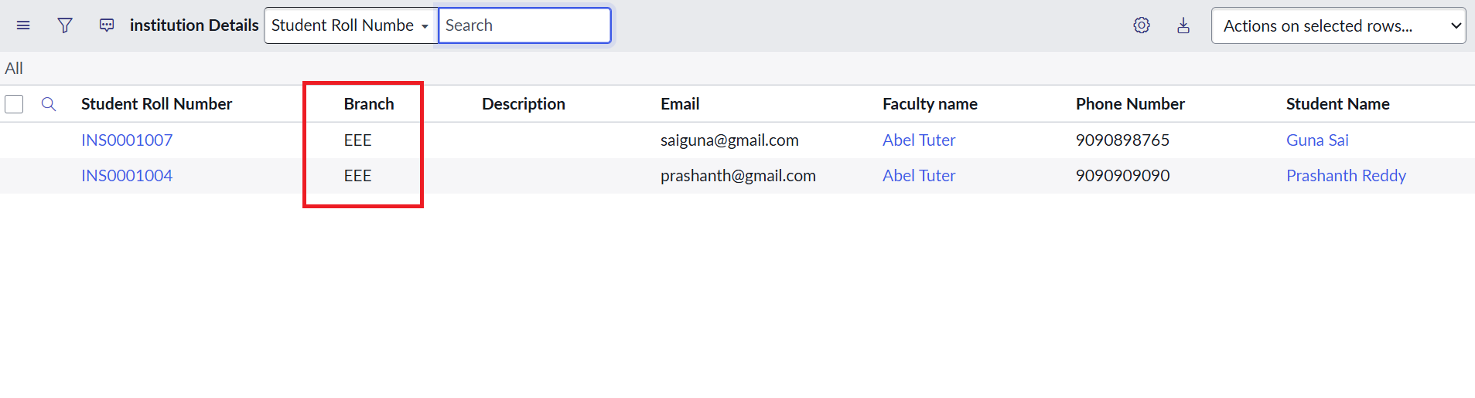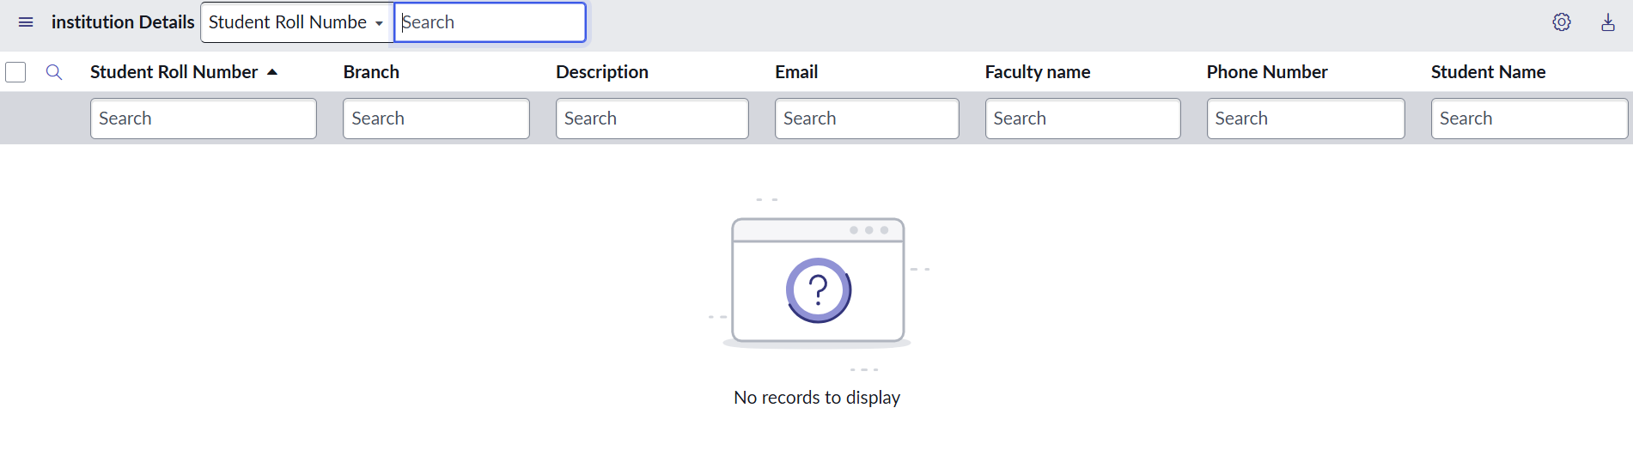
2 | Create ACL | bb1 + bb2 roles: New/Create access available for Institution Details records. | 
3 | Write ACL | bb1 + bb2 + bb3 roles: EEE records can be viewed and edited. | 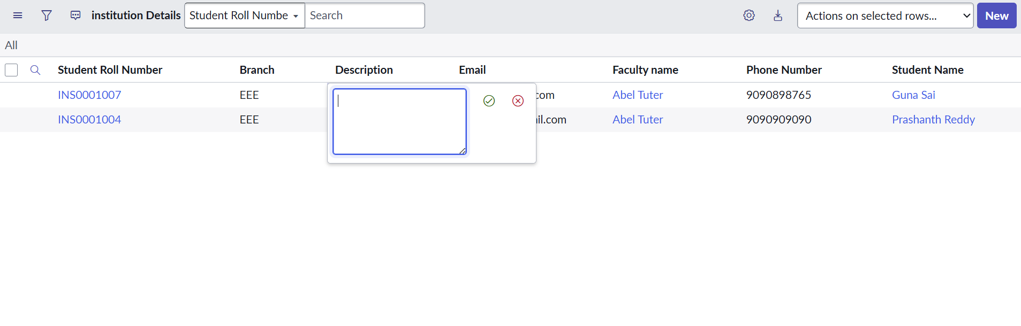
4 | Delete ACL | bb1 + bb2 + bb3 + bb4 roles: EEE records can be deleted. | 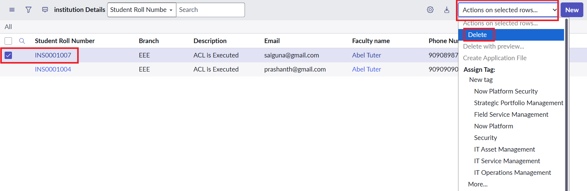
5 | Role / Condition Validation | Access is controlled by the required role(s); the Read ACL uses the EEE branch condition and admin retains full access. | 
6 | Hyperparameter Tuning | Not applicable – this is a ServiceNow ACL/security project, not a machine-learning model. | N/A
7 | Validation Method | Impersonation-based validation using EEE user, users without required roles, and Admin; verify list/form access and CRUD operations. | To be attached

Project Verification Summary
- Custom table: u_institution_details
- Branch choices: ECE, EEE, CSE
- Read ACL: bb1
- Create ACL: bb2
- Write ACL: bb3
- Delete ACL: bb4
- Administrator: full access
Expected Outcome:
The ACL configuration should ensure that authorized users can perform only the operations permitted by their assigned roles, while unauthorized users are prevented from accessing or modifying restricted records.

